**TEMPERATURE MONITORING SYSTEM**



**Shreya**

Things required :-

## Hardware components

* Bolt IoT Bolt WiFi Module

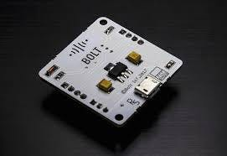

**.** LM35 IC

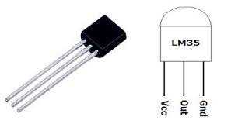

**.**Jumper wires (generic)

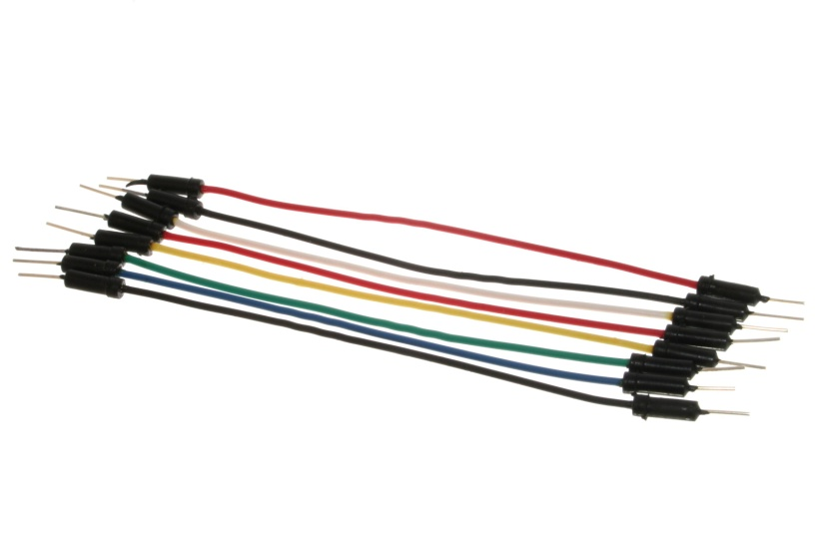

## Software apps and online service

BOLT IOT CLOUD

Let's get started and build our system

## Step 1: Connecting LM35 to Bolt

Follow the connections as mentioned below. It as easy as saying 1, 2, 3. You can refer the pin out of the LM35 sensor as shown below,

1. Make sure you have not powered on your Bolt Module white connecting the circuit. This will ensure that in case we make any mistake, it will not short circuit your device. Switch off the power if it is connected.

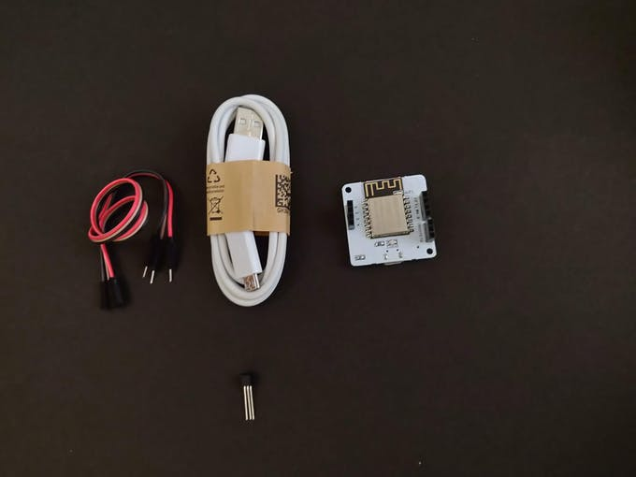

1. Connect the VCC pin of LM35 to 5V pin of the Bolt device 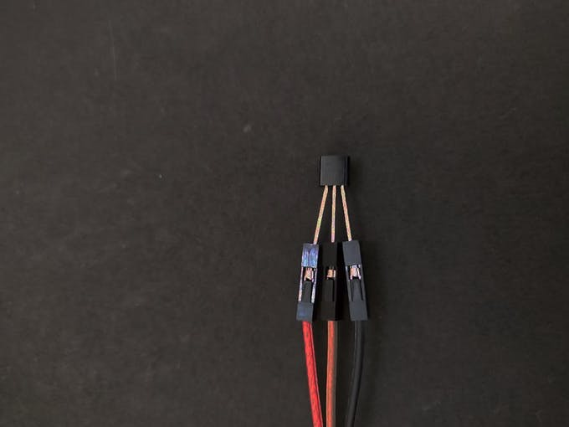
2. Connect the GND pin of LM35 to GND pin of the BOLT device

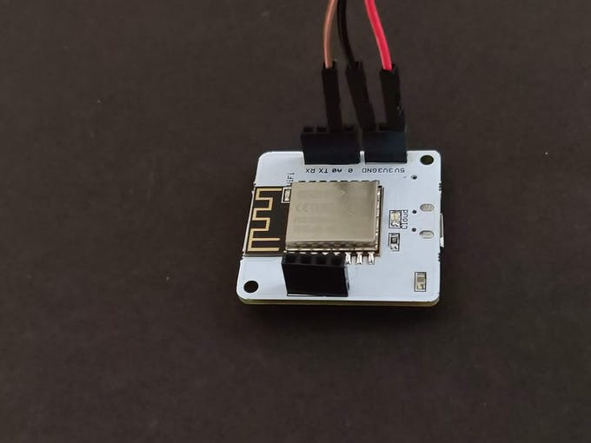

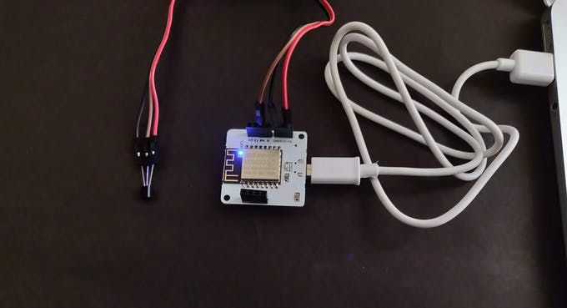

### Step 2: Visualizing the plot

Now we need to visualize the temperature data on the Bolt cloud.

For the steps to make a line graph go on https://cloud.boltiot.com/

### CODE

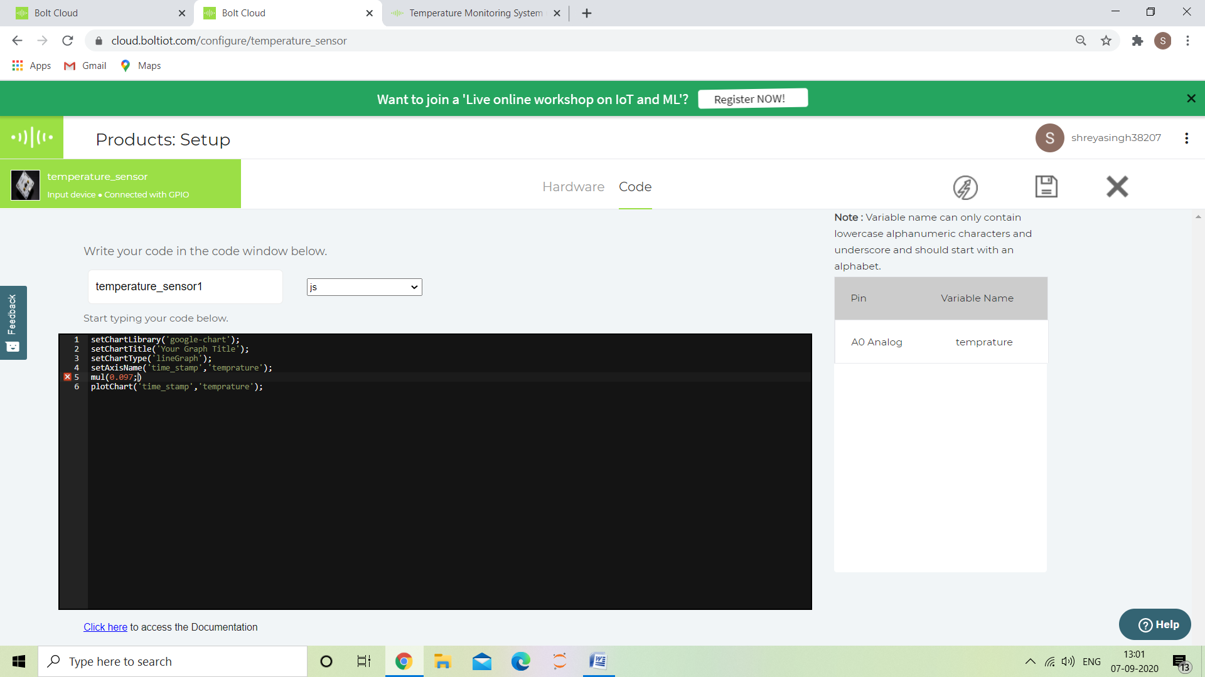

Now let me explain each line of the code so that you could make suitable changes as you wish.

**setChartLibrary** function sets the Data Visualization Library you would use. The most commonly used one on Bolt Cloud is the Google Library. However, you could use any other JavaScript or HTML code here to visualize the data.

**setChartTitle** function sets the Title of the Chart/Graph. Give a suitable name for your graph here which will be shown in the heading of the page. This is different from the name of the code **setChartType** function is where you choose which type of chart you want i.e. Line Graph, Bar Graph etc.

**setAxisName** will set the name for the X Axis and Y Axis

**plotChart** is where you choose which variable you want to choose in your chart.

We have added an instruction mul (0.097) before the plot chart function to convert Fahrenheit into Celsius .

Working principle

The working principle of the system is quite easy. Let understand it.

Here in our system, LM35 is the sensor that senses the temperature of its environment and based on it's value it generates an analog output voltage. This analog voltage produced by the LM35 is then given as input to the Bolt A0 pin. The Bolt then converts the analog value into a 10 bit digital value that varies from 0-1023. This digital data is sent to the cloud via Bolt device.

Hence, while plotting the temperature, it is required to convert the raw sensor values into the actual temperature value, which is done using the given formula:

temp = (analog_value100)/1023*

**OUTPUT PLOT**

I set the room temperature to 30 C by switching on the AC and then put the sensor in that room for 2 min the temperature which the temperature showed was 29.4 C as shown in the graph

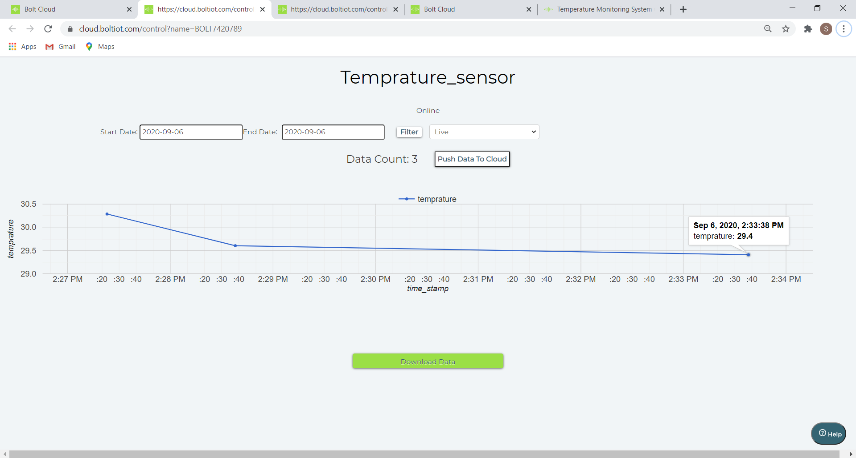

THANK YOU